Robert D. Rustia

5/17/2020

Module 1

Kickstarter data outcome analysis

From the data represented on the Outcomes based on start date graph it is clear that August is the best month to start a kickstarter in the in Theater realm. The graph shows 83 Kickstarters finding success while a 37 failing. This difference between the two outcomes from kickstarters initiated in August is 46. Another way to represent this data from the graph is to say there are over two times as many kickstarts that succeed than fail when started in August(83 / 37 = 2.24). 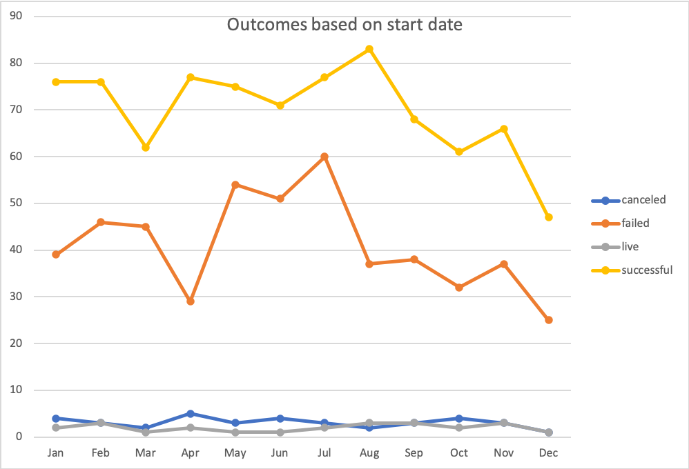

The other interesting trend to point out on the graph about is that in May, June and July there are relatively close amounts of successful and failed kickstarts initiated. We could advise Louise to steer away from those months as there is a clear increase in change of failure in those months.

The last piece of information that jumps out at me was that April has a large amount of successful kickstarts compared to the amount of failures so If Louise couldnt start in August I would suggest waiting till April but not until May where failures increase again.

From the data placed in the outcomes based on goal line graph that 71 % of a kickstarters succeed that are below the 1000$ mark, and 67% of kickstarters succeed that have goals between 1000 and 5000 , and 53 % of kickstarters between 5000 and 10000 find success. There is a clear inverse relationship between goal and success as there is a decline in percentage of success as the goals are increased.

As well as there is an inverse relationship between goal and success there is a direct relationship between the percentage of failed kickstarters and goal. Goals between 1000 and 5000 have failed 29% of the time while goals between 5000 and 10000 have failed 40 % of the time. We see this direct relationship of increase in percentage failure continue up to 25000 but stay above 40 % for the rest of the inscread goal range.

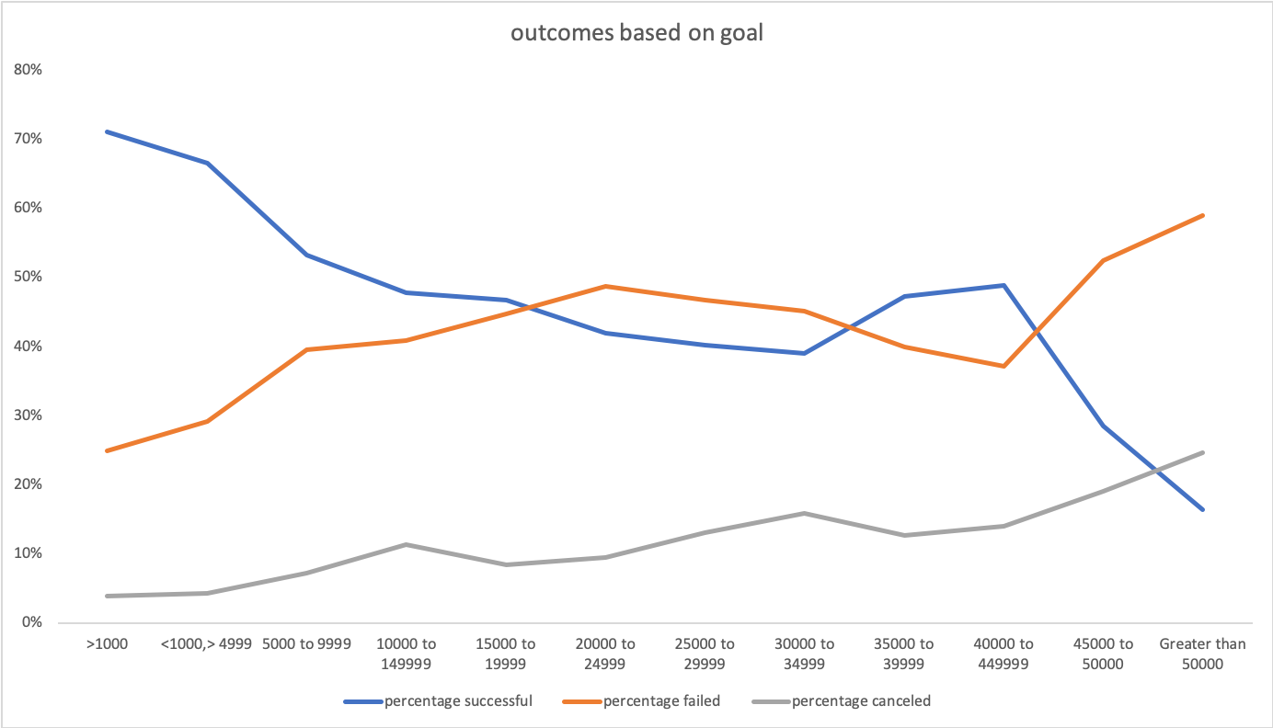

One limitation of this data set is not divided into percentage of outcome by month in specific countries as Louises only needs her play to be successful in one place and we could drill down to find out which month is the best starting month for her specific location. A comparison by a line graph showing different countries' success rates by month could allow for Louises to see where and when she would want to start different kickstarters.

A second limitation is that the data shows only kickstarts and not other methods of crowd funing. There could be other methods of obtaining funding that is being overlook and not being accounted for what so ever. Other forms of funding might be easier and more prevalent in the theater community. This possibility is not taken into consideration from our data only being from kickstarters.

In conclusion It is clear that her goal of 4000$ if more likely to succeed than if she was to increase her goal past 5000. It is also clear that starting her Kickstarter in August will have the largest success rate followed by April. The months of May june and July have the largest percentage of failures and should be avoided if possible.